**Madagascar Travel Tips & Advice**

**Money & Spending**

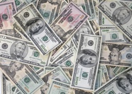

[This Photo](https://www.flickr.com/photos/tracy_olson/61056391) by Unknown Author is licensed under [CC BY-SA](https://creativecommons.org/licenses/by-sa/3.0/)

The currency in Madagascar is the Malagasy ariary but you can use euros for almost all tourist-related costs. Make sure to have some euros in cash.

It is also best not to rely on credit cards as they are not accepted widely.

**Tipping**

Tipping is voluntary in return for good service or assistance. It is usual to tip drivers, servers, and tour guides. Gratuities should be in euros, if possible.

**Climate**

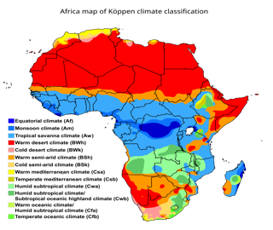

[This Photo](http://en.wikipedia.org/wiki/Climate_of_Africa) by Unknown Author is licensed under [CC BY-SA](https://creativecommons.org/licenses/by-sa/3.0/)

It is usually hot and rainy between about November and April (summer), and colder and drier between about May and October (winter).

January is generally the hottest month with an average temperature of 22°C / 72°F while July is the coldest at about 15°C / 59°F. December is the rainiest month.

**What To Pack**

Tourism is not well developed in Madagascar so it is important to pack thoughtfully as you will be unlikely to be able easily buy items you forget once you leave Antananarivo.

Essentials include:

* Comfortable clothes in neutral colors. Be respectful and avoid revealing clothing.
* Hat or cap and sunglasses.
* Swimsuit.
* Sunscreen
* A camera with a good zoom for photographing lemurs.
* Binoculars are helpful for spotting lemurs and birds.
* Hiking and tennis shoes.
* Medications. Malaria pills are recommended.
* Insect repellent.

**Respect**

* Obey local customs around entering churches or mosques.
* Ask permission to take pictures of people
* Dress Modestly
* Remember that English is not widely spoken
* Discuss with your guide the giving of money, candy, etc.

**Flights & Getting Around**

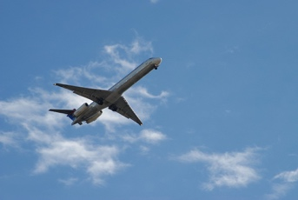

Research flights to find the best and most direct flight from your area.

In country, hire a guide. It is not a place where self-driving is recommended.

Madagascar is a big country. Journeys will generally include flying and road transfers in 4x4s or ‘mini-buses.

**Visas & Passports**

See <https://www.visiting-madagascar.com/> for visa information.

**Interesting Facts**

**Government**

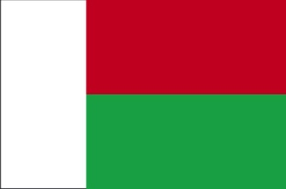

Prime Minister: Christian Ntsay

Head of State: President: Andry Rajoelina

Capital: Antananarivo

Population: (2024 est.) 30,854,000

Form Of Government: republic with two legislative houses (National Assembly and Senate.

**Culture**

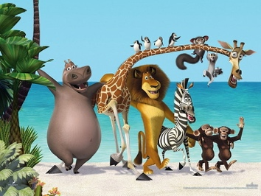

More than nine-tenths of the population is Malagasy, which is divided into about 20 ethnic groups.

Most inhabitants of Madagascar speak Malagasy, the national language, which is written in the Latin alphabet.

**Religion**

Almost half of the population is Christian. Conversion to Christianity has not eliminated the observation of traditional religious rites, however, particularly those involving the dead. A community of Sunni Muslims is found in the northwest.

**Wildlife**

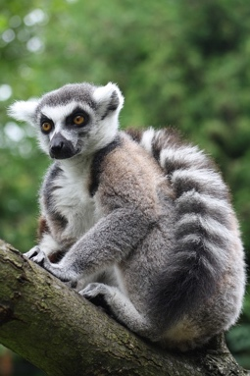

The species most closely associated with Madagascar are lemurs, a type of primate that are distinct from apes and monkeys.

 About 40 species of lemurs are indigenous to Madagascar.

There are also many kinds of chameleons.

Birds include, partridges, pigeons, herons, ibis, flamingos, egrets, cuckoos, Asian robins, guinea fowl and several kinds of birds of prey.

There are about 800 species of butterflies, many moths, and a variety of spiders.

The only large or dangerous animals are the crocodiles, which occupy the rivers.

The snakes, including the do, which is 10 to 13 feet (3 to 4 meters) in length, are harmless.

**Agriculture**

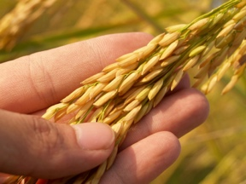

Rice occupies the largest share of total crop acreage. Many varieties of dry, wet, and irrigated rice are grown in the central plateau; dry rice is also grown in the eastern forests and wet rice in the lower river valleys and along the estuaries, mainly by populations who migrated from overpopulated parts of the plateau.

**Manufacturing**

The country’s manufacturing industry processes products such as textiles and footwear, wood, paper pulp fertilizer, oils, soap, sugar, cigarettes and tobacco, beer, cement, and foods and beverages. Industrial centers are located mainly in and around Antananarivo, Antsirabe, and Toamasina.

**Infrastructure**

The majority of roads are unpaved. Roads down the eastern escarpment and across the western coastal strip, as well as minor roads everywhere, become impassable during the wet season.